Numeracy topic- Reasoning about number or shapes
This term we will be looking at why numbers and shapes are used in everyday life. 2D shapes link to watch for children https://youtu.be/OVItzLoovLc , this will help show sides and where we see them. 3D shapes link to watch for children https://youtu.be/QwRe_8c1OXo and shows a trip to the beach with common 3D shapes. Concentrate on sides for 2D shapes and faces for 3D shapes. Below are tables to show 2D and 3D shapes and their main information.
Circle- 1 curved side 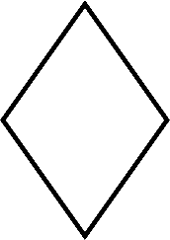Rhombus- 4 sides
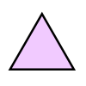  Triangle - 3 Sides | Square - 4 Sides
Pentagon - 5 Sides | Hexagon - 6 sides
Name | Faces
Cube 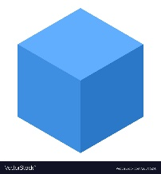 |  |  | 6
Square-based pyramid 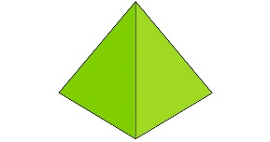 |  |  | 5
Triangular-based pyramid 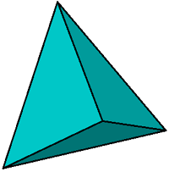 |  |  | 4
Cuboid 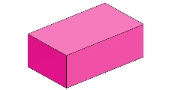 |  |  | 6
Cylinder 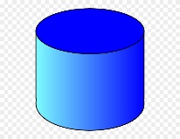 |  |  | 3
Cone 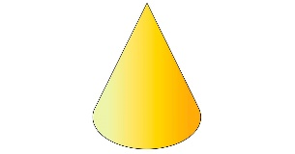 |  |  | 2
Sphere 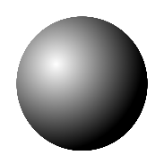 |  |  | 1

It is also important to question children on this, for example does a triangle have 3 sides? If they answer correctly assure their confidence and if incorrect perform again providing support by counting out together. It helps with problem solving and using the correct methods to perform a task successfully. A follow up task for this would be questioning type game for all 2d and basic 3d shapes (Cube, cuboid, cone, sphere, pyramid and cylinder) for example what am I game? *I have 3 sides, what am I?*
Writing the shape name is important to perform. Either hand over hand, overwrite or copy underneath. This will help with muscle memory and fine motor skills.
Extension task
Can you go and find these shapes in the house. Count how many you can find in each room of the house over a timed period. Then move onto size order, for example cupboard is the biggest, so we can put lots of food in.
Test the children’s understanding, for example shape sorters and ask to find the square but give the child a circle.
2D Shapes
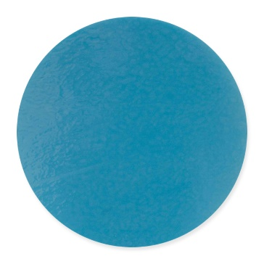

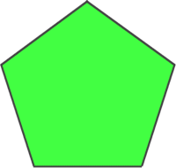

Nets for the 3D shapes- colour in the shapes before making.
Cube- fold all squares into middle square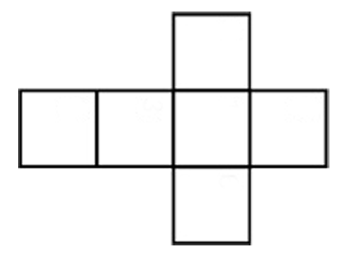
Cuboid- Fold squares up and then rectangles

Square based pyramid- Fold all triangles up
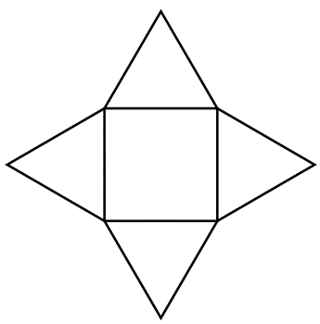

Triangle based pyramid- Fold all outside triangles up.
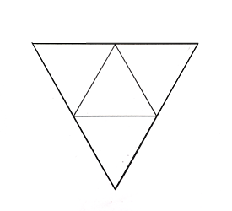

Cone- Fold circle towards triangle and wrap triangle round.
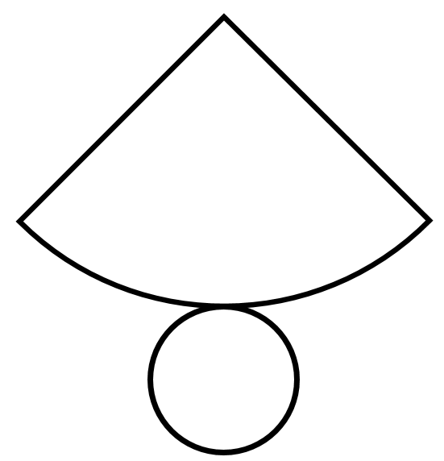

Cylinder- Fold circles in towards rectangle and wrap rectangle round.
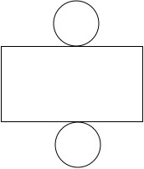

Number reasoning
Here we will look at counting, number sequences and problem solving (how many forks for tea?). Practising this type of work will help with number recognition, how to follow instructions/sequencing events and encourage more independence when problem solving.
Counting is important, but number recognition is essential and constant practice will improve this skill. Count as many objects in the house as possible, for example socks, spoons, cushions etc. Underneath is a number line start by moving forward in ones and placing a counter underneath each number.
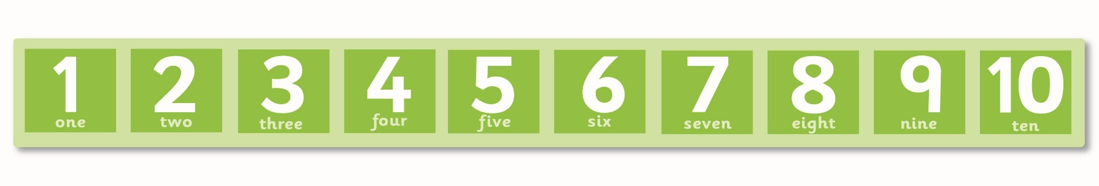

Sequencing can be done with anything and should have a minimum of 3 things to sequence. Examples in the house are; kitchen- cutlery at the table follow a sequence of knife, fork, knife and fork. Living room- cushions. Bedroom- a set of toys (train, car, train, car). Garden- ball, cone, ball. It can be also be a routine (like the washing hands picture in the previous home link pack).
Extension for number patters- Move onto 2’s, 3’s, 4’s and 5’s up to 10. This will show multiplication and sequencing. Below is the number of items needed
Number of counters for counting in:
2’s- 30 (can work with 12 just finish at 6)
3’s- 18
4’s-12
5’s- 15

The possibilities are endless with sequencing, as you can use anything you have more than three of and it can be very random. You can go further with sequences with shapes and pictures.
Extra help
Utilise everything in your household and if you feel you can order resources related to the topic then that would be fantastic. The websites below are fantastic and interactive learning can really engage your children.
TWINKL
Great website- Go to www.twinkl.co.uk/offer and type in CVDTWINKLHELPS or PARENTSTWINKLHELPS
You will then sign up to Twinkl and utilise a huge number of their resources. Key searches- sequencing, counting and shapes (if you cannot print just open the document and ask pupil to point in order).
Top marks
Is a great interactive site which has everything you need for shapes, ordering and sequencing. When on the page you can see the links to click on at the top.
https://www.topmarks.co.uk/maths-games/3-5-years/ordering-and-sequencing#
https://www.topmarks.co.uk/maths-games/5-7-years/counting
https://www.topmarks.co.uk/maths-games/3-5-years/shape-position-and-movement
https://www.topmarks.co.uk/maths-games/5-7-years/shapes
Splash games
https://www.splashlearn.com/counting-games
https://www.splashlearn.com/geometry-games

