Music
Music is a great way for pupils to learn patterns, improve receptive skills and improve fine & gross motor skills. We will be looking at action songs for children to copy and there are huge number of these on Youtube, as well as other children’s programmes. With there being so many videos to copy from there will be varying levels of difficulty, so test this by following videos in order below. Search the keywords in the Youtube search bar and look for the corresponding picture below the link.
WARM UP
Always perform a warm up, as this will help children follow a simple pattern of movements to prepare their body for exercise. Your children will love this video, as we performed it each week when Everton FC provided a class in school.
Shake our sillies out (3:09 mins) https://www.youtube.com/watch?v=03zqJQJRLN0
Lesson 1-2
After the warm up we will start following routines from small 1-2 minute clips. This activity will take 10-15 minutes and songs can be repeated or skipped depending on your child’s enjoyment. All of these activities promote gross motor skills;

Little Wizard- Copy me (1:14 mins) https://www.youtube.com/watch?v=Ifz6iYKJPm0
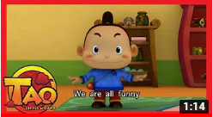
Bul Bul tv- Copy me (1:39 mins)- https://www.youtube.com/watch?v=yeXbOznIop0
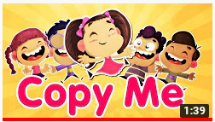
Super simple- Walking walking (1:52 mins) https://www.youtube.com/watch?v=fPMjnlTEZwU
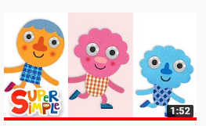
Talking flashcards- Action words (1:30 mins)- https://www.youtube.com/watch?v=hzo9me2fdzg&list=PLh0N0TQYvEUCVPBhzfjPz5nAZYdnX7X2c&index=12

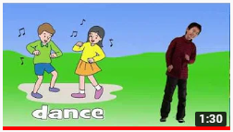
The Tweenies- Copy me do (2:18 mins) https://www.youtube.com/watch?v=hSMZIQ-gln0
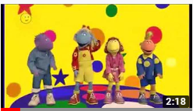
Lesson 3-4
Will be working on fine motor movements, so concentrating on our dexterities and smaller movements. They will improve hand mobility, resulting in more strength in their wrist and control when writing. When working with feet it will help aid balance and performing tasks easier like putting on shoes.
Finger aerobics (1:22 mins) https://www.youtube.com/watch?v=3VpARNgbb8c
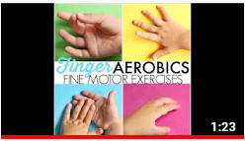
Super simple- One little finger (2:24 mins) https://www.youtube.com/watch?v=eBVqcTEC3zQ&list=PLh0N0TQYvEUCVPBhzfjPz5nAZYdnX7X2c&index=3
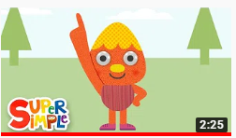
Learning station- One finger, one thumb keep moving- (3:32 mins) https://www.youtube.com/watch?v=osIVAVlgLpc
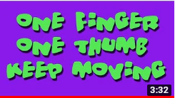
LESSON 5-6
We will be looking at party like songs that include fine & gross motor movements, balance, receptive skills, reaction time and hand eye co-ordination. The songs chosen have movements that children can perform due to its repetitive nature. This section will provide children the chance to follow a pattern and work as a team.
Kids songs- Chu Chu ua (3:40 mins) https://www.youtube.com/watch?v=98xd3SAVujk
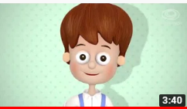
Super simple- Walking in the jungle (3:25 mins) https://www.youtube.com/watch?v=98xd3SAVujk
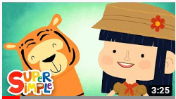
Super simple- Pinocchio song (3:25 mins) https://www.youtube.com/watch?v=JV-D_K4drsA
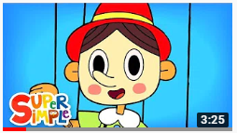
The Singing Walrus- Action song (3:39 mins) https://www.youtube.com/watch?v=dUXk8Nc5qQ8
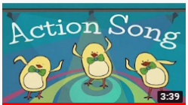
The Singing Walrus- Jump, Run and Shout (3:21 mins) https://www.youtube.com/watch?v=hft6uJQIF4g
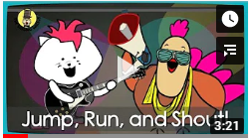
Advanced movements
The songs below have movements which can be quite tricky and will challenge your child. Some classics with a twist to make it more accessible, as the older videos are not easy to follow. You can add your own songs if there are any that you feel I have missed.
Do the bear walk (4:13 mins) https://www.youtube.com/watch?v=KG3AO6lJ4BQ
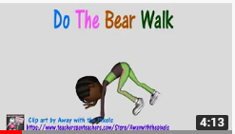
Go noodle- The Maxarana/Macarena (3:16 mins) https://www.youtube.com/watch?v=MAsP7TYPYcc
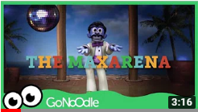
Go noodle- Chicken/Birdie song (3:16 mins) https://www.youtube.com/watch?v=npp1z32idrc
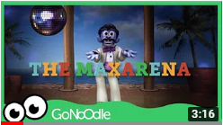
Learning station- Move and freeze (4:01 mins) https://www.youtube.com/watch?v=388Q44ReOWE
